Basic Linux Commands

1: ls



2: cd



3: mkdir



4: ls -l

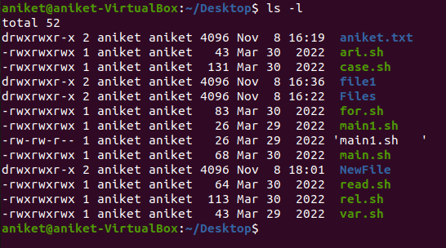

5: ls -a



6: pwd



7: touch aniket.txt



8: cat aniket.txt



9: whoami

